Application for a coursework deadline extension


This form should be used by students requesting an extension to a coursework deadline. An extension of up to 5 university working days can be granted. A shorter extension should be considered if appropriate.

If you require an extension for a longer period, you will need to apply for a deferral by submitting a deferral request form.

An extension will only be granted in the circumstances outlined in Appendix 2 of the Academic Regulations, and evidence should be supplied to support the application. Where an extension is granted, failure to meet the deadline will result in penalties as outlined in Section 5 of the regulations.

The form should be emailed to your module leader or nominated alternative no later than 24 hours before the date/time that the assessment is due to be submitted, with the evidence attached.

Section A – student to complete

Student information
Last name
First name
Student ID number

Programme information
Programme name
Year/level of study
Campus

Module information
Module code
Module name
Assessment component
Original deadline date
Reason for request

It is recommended that you password protect this form and any accompanying evidence when submitting to your module leader/module tutor, as they may contain personal information. Guidance on how to do this is provided in the Appendix to this form. Please remember to provide the password to the module leader/tutor in a separate email.

Section B – module leader to complete

Module leader/tutor to complete and return to student. Please refer to the guidance in Appendix 3 of the academic regulations: dmu.ac.uk/scheme-regulations
12 | Extension approved Y/N |  | (If no, please provide rationale)
13 | New deadline date
14 | Name |  |  | Signature |  | Date

If the extension is approved please ensure that the relevant assessment markers are informed in order that the 20-working day turnaround for the provision of feedback can be adjusted to reflect the revised deadline.

Protecting electronic files using a password (Word/Excel/PDF)

Protecting your file with a password will prevent unauthorised access to the content. The file will not open unless the correct password has been entered.
The process of protecting your documents/worksheets with a password is the same in Word and Excel. The following seven steps can be used in both products. The instructions for password protecting PDF documents are at the end of this Appendix.

Step 1.

From the menu tab, select File

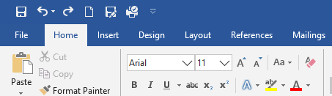

Step 2.

From the menu pane on the left, select Info:

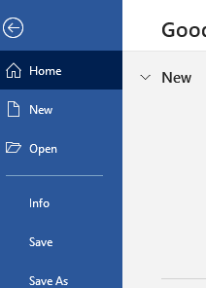

Step 3.

On the Info screen, select Protect Document (in Word) or Protect Workbook (in Excel)

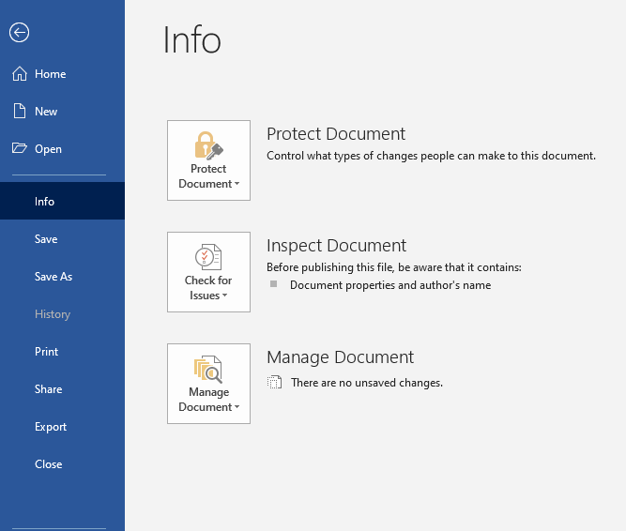

Step 4.

From the options, select Encrypt with Password.

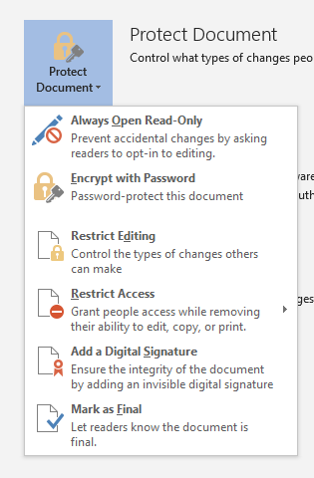
Step 5.

In the next window, enter the password you wish to use to protect the document – remember it is case sensitive and can only be a maximum of 15 characters long. After entering password, click OK to continue.

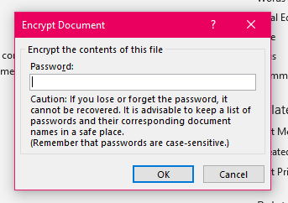

Step 6.

You will be asked to re-enter the password at the next screen.
After re-entering password, click OK to continue.

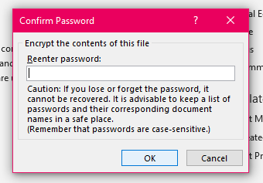

Step 7.

Once the password has been set you should see the following change on the Info screen.

In Word:
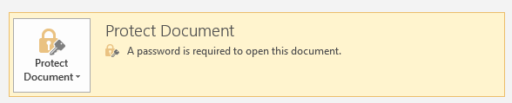

In Excel:
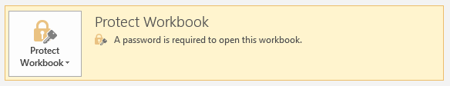

NOTE: If you lose or forget your password, Word/Excel will not be able to recover it for you. Please be sure to keep a copy of the password in a safe place or create a strong password that you’ll remember.

To access a password protected document, open the document/worksheet and when prompted, enter the password you have been provided and click OK to continue.

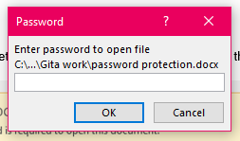

PDF documents

To restrict access to a PDF document:

Step 1

Open your PDF document in Acrobat

Step 2

Go to the File tab and select ‘Protect Using Password’.

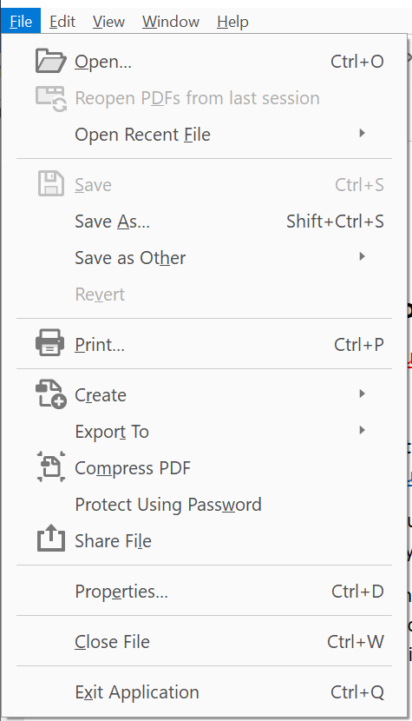

Step 3

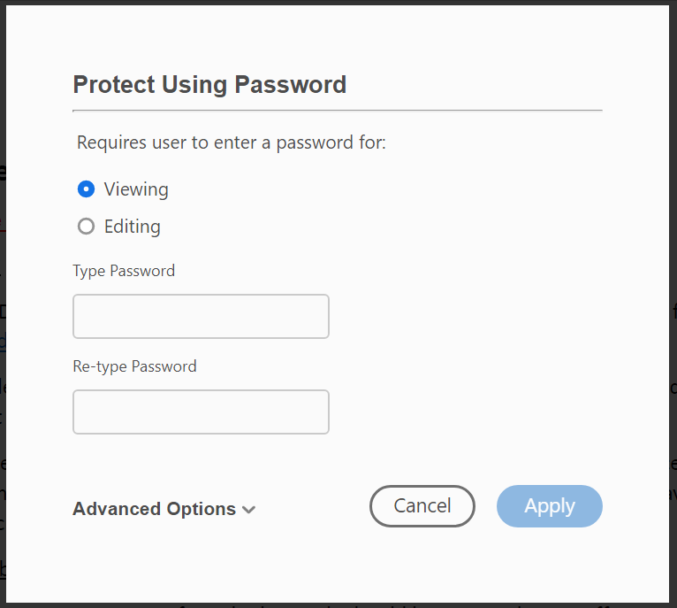

From the window above, choose one of the following options:

- To prevent users viewing the content unless they have the password, click the button against ‘Viewing’.
- To prevent users from making any changes to the content unless they have the password, click the button against ‘Editing’.

Step 4

Type in the password you want to use and then re-type the password when prompted to confirm. Click ‘Apply’ when finished.

NOTE: The password strength is displayed next to your password to indicate whether the chosen password is weak, medium, strong, or best. If you forget the password, you cannot recover it from PDF.

At the bottom of the screen, you will see that the password protection was set up successfully:

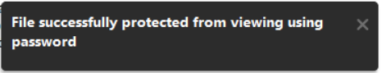 or 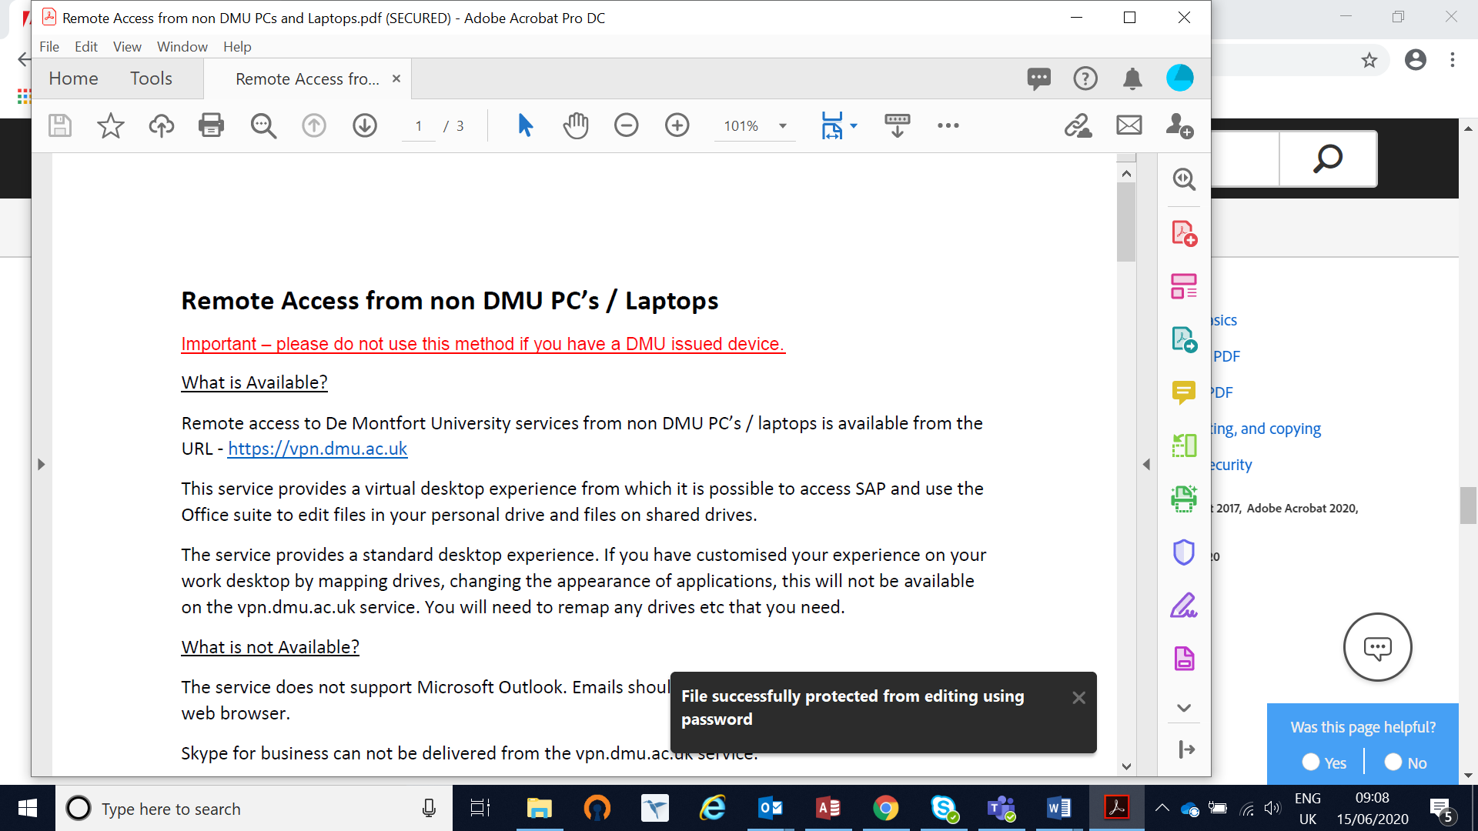

Step 5

Now, when a user attempts to view or edit the document, they will be prompted to enter the password before they can continue.

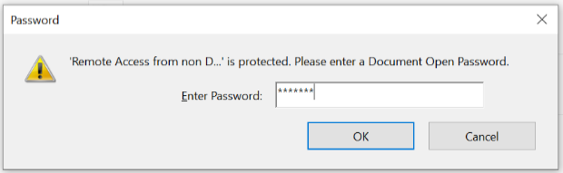

NOTE: Setting these restrictions does not prevent someone saving copies of the PDF. However, the copies will have the same restrictions as the original PDF.

