MFA Setup Step By Step Guide
______________________________________________________________

If you have had your MFA reset and had the Microsoft Authenticator app setup before, please ensure you remove your account from the app before trying to setup your MFA again.
If this is your first time setting up MFA, you can ignore these steps.
Remove Account from the Microsoft Authenticator App
- Open the Microsoft Authenticator App. You DMU account should be listed (as shown in the image below). Select the account.
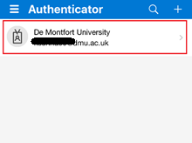

- Select the cog wheel in the top right.
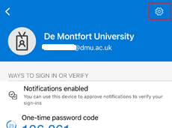

- Select the option to remove account.
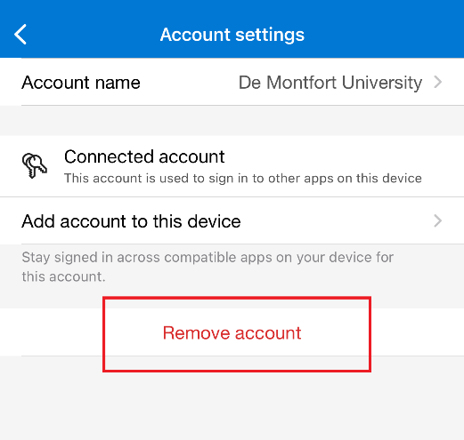

Setup MFA using the Microsoft Authenticator app.

- On a web browser, go to https://aka.ms/mfasetup and sign in with your DMU email address.

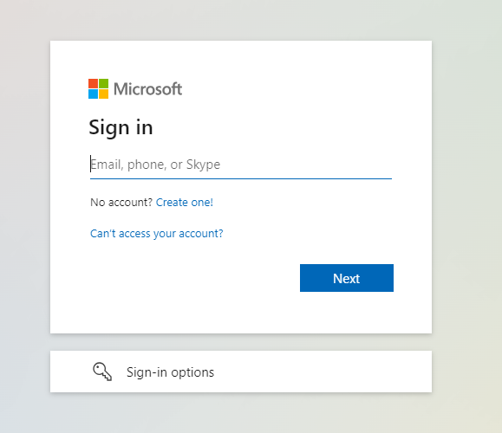

You will then see the De Montfort University Web Services page (as shown in the image below). Enter your DMU username and password and Sign in.

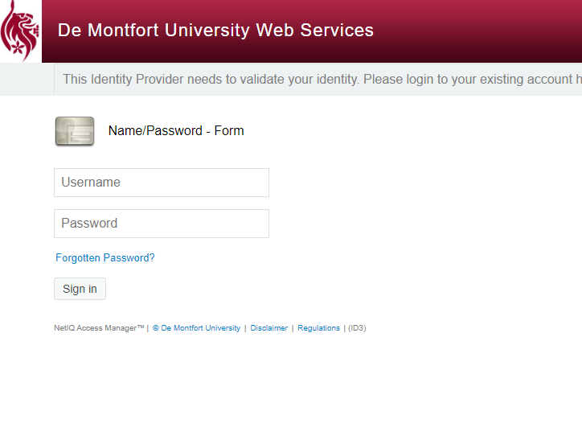

- You should then see a screen like in the image below. Select ‘Add sign-in method’
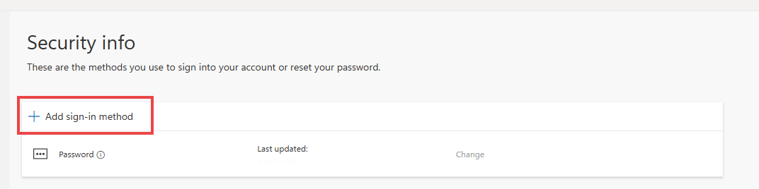

- Choose Microsoft Authenticator from the list
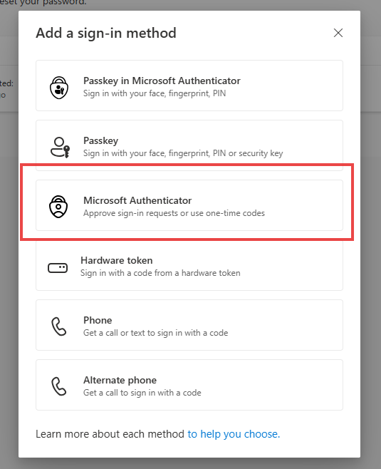

- You will then see the below screen. Download the Microsoft authenticator app on your mobile device and then press Next on the screen below.
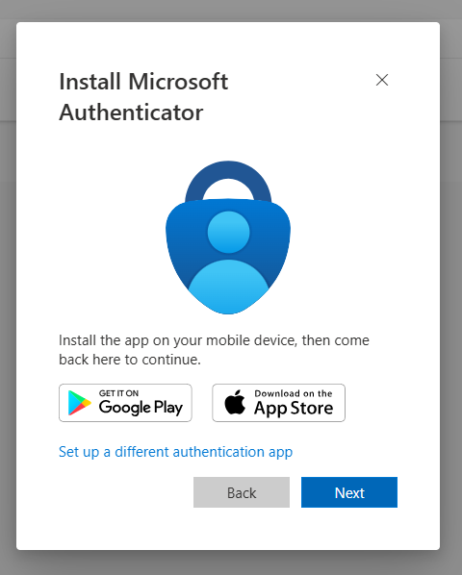

- You will then see the below screen. Follow the 3 steps below and the press Next.
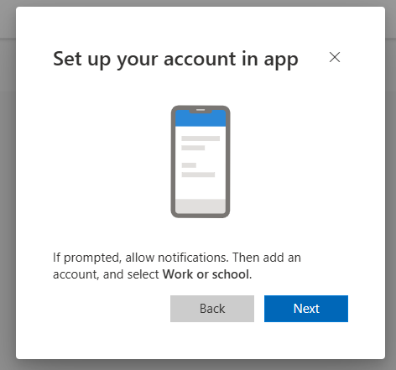

- Open the Microsoft Authenticator app on your phone.
- Click on the + icon in the top left.
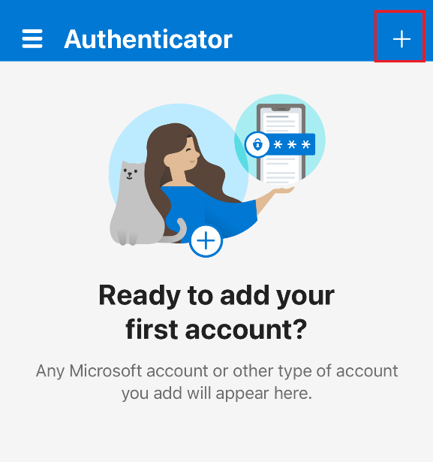
- Choose the option to add ‘Work or School account’
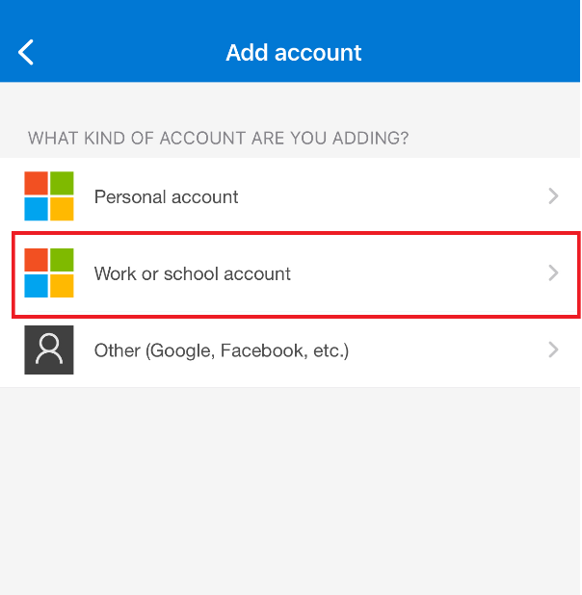

- Select the option to ‘Scan QR code’
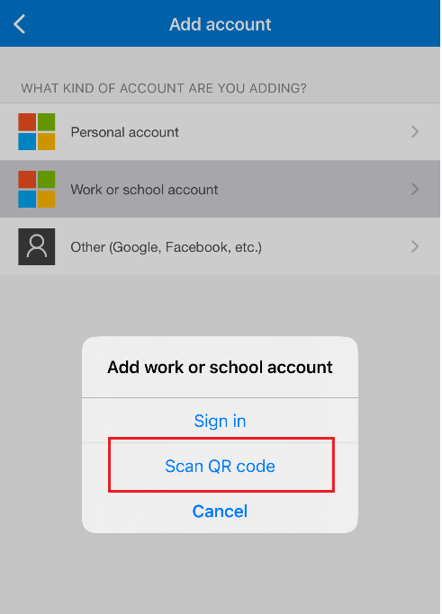

- You will see a QR code on your computer screen (like below). 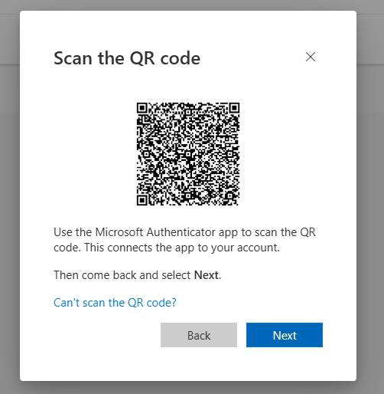
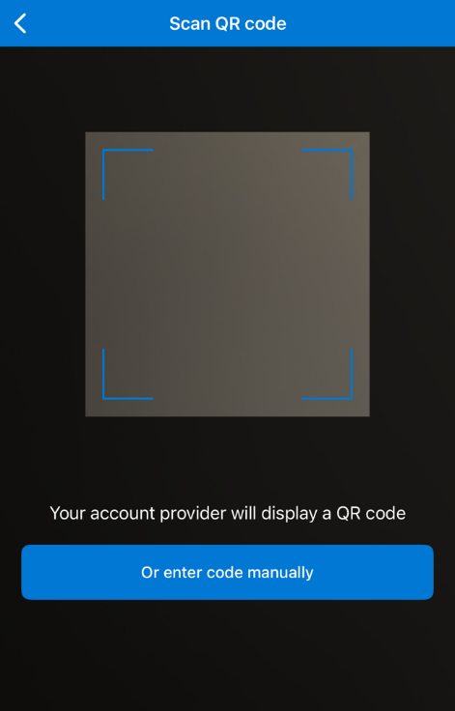
Using your phone, scan the QR code on your computer screen and then press Next.

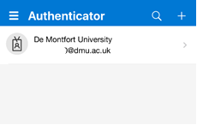
You will see your account added to the Microsoft Authenticator App

- On your computer screen press Next.
You will get a number appear on screen like below.
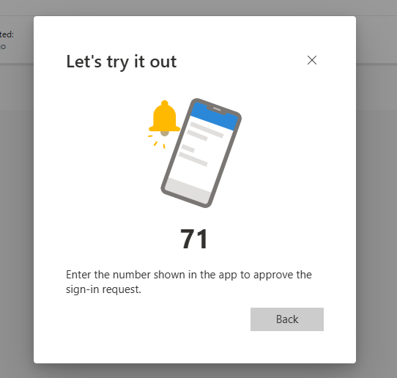

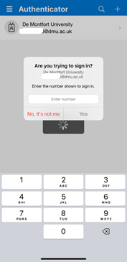
You will also get a box appear on your phone (as shown in image).
Enter the number appearing for you into the box on your phone and then press Yes.

- On your computer screen press Done.
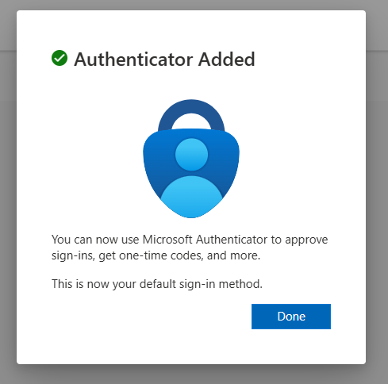

Now your MFA has been set up via the Microsoft Authenticator App

Setup MFA using the Text option.
- On a web browser, go to https://aka.ms/mfasetup and sign in with your DMU email address.

You will then see the De Montfort University Web Services page (as shown in the image below). Enter your DMU username and password and Sign in.

- You should then see a screen like in the image below. Select ‘Add sign-in method’

- Choose Phone from the list
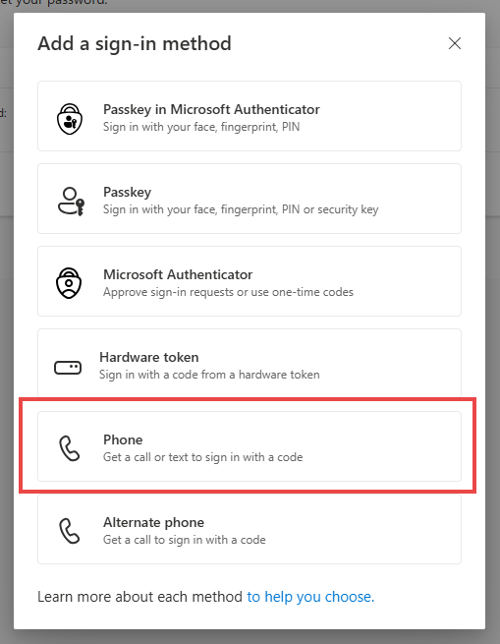

- You will then get the below screen. Please ensure you; select the correct Country Code. enter your mobile number and choose the option ‘receive a code’. Then Press Next.

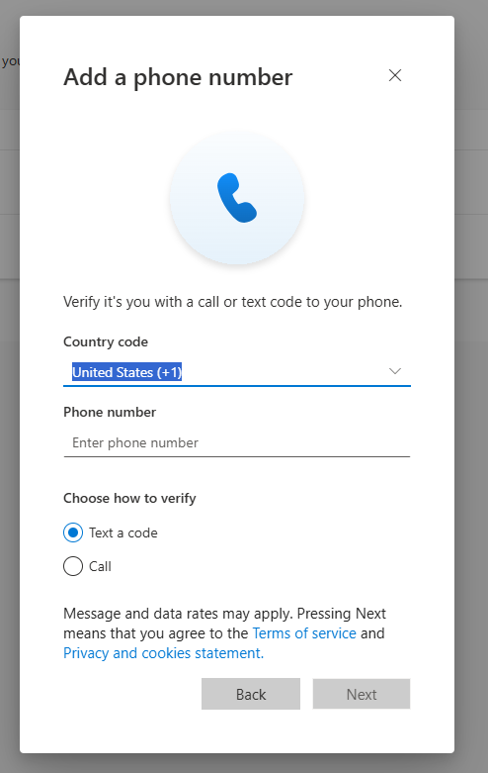

- You will then see the below screen. Enter the code you receive via a text on your mobile and then press Next.
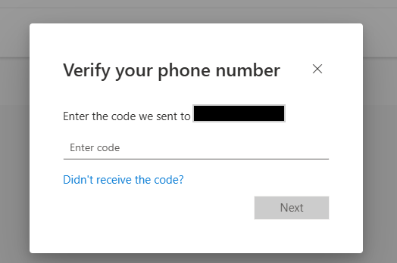
- You will then see this page which confirms that your phone has been registered. Press Done.
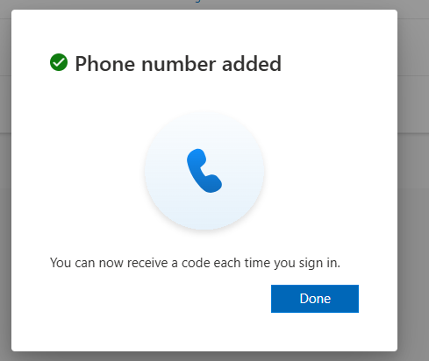
Now your MFA has been set up via Text.

Possible Errors.
You have changed your number or phone. Call the Service Desk on +44 116 250 6050 option 2 or visit the Digital & Technology Service Desk, located in the Kimberlin Library, on the Ground floor between the hours of 9-5pm Monday to Friday, to get your MFA reset.
You have tried to setup your MFA too many times. Trying to setup MFA incorrectly too many times can block the account from registering onto MFA. The Service Desk will need to contact the Unified Comms Team to unblock the account before trying again.

